|  |
| --- |
| **National University of Computer and Emerging Sciences** |
| In Lab Exercise 7  “Stored Procedures” |
|  |
| Database Systems |
| Spring 2018 |

Department of Computer Science

FAST-NU, Lahore, Pakistan

**Lab Mid in the Next Lab**

**3/16/2018 Friday in Regular Lab Session**

**2:00 pm to 5:00 pm in Lab-9**

# Exercise

For this exercise use the following schema, the script to create this schema and populate data is given in ATM.SQL file

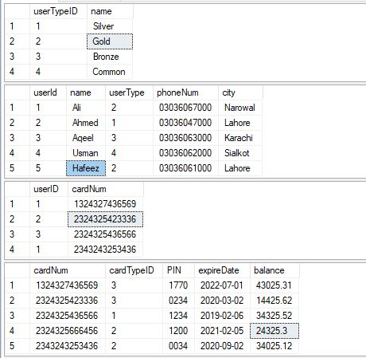

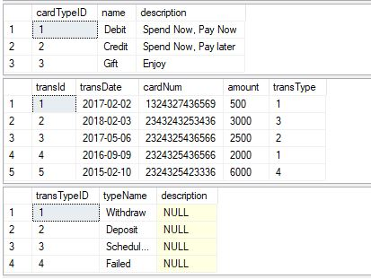

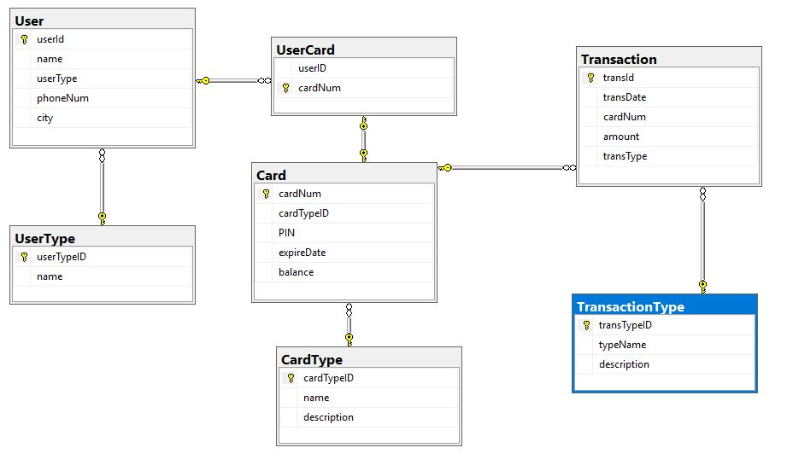

**Write script to execute PROCEDURE for each question.**

1. Create a procedure to display all the users details.
2. Create a procedure that takes user name and display his details.
3. Create a procedure that takes card number and display owner’s **name, phone number and city**.
4. Create a procedure that returns minimum balance in an output parameter.
5. Create a procedure that takes user name, id and returns no. of cards of that user in an output parameter.
6. Create a procedure Login that takes card number, PIN and returns the status in an output parameter. @status =1 if card number and PIN is valid and @status=0 otherwise.

(Hint: IF/ELSE).

1. Create a procedure to update the PIN. The procedure takes Card Number, old PIN and new Valid PIN (Length 4) and print ‘Updated PIN’ if PIN gets updated and ‘Error’ otherwise.

**(Google it if you don’t know how to compare the Length)**.

1. Create a procedure **WithDraw** using Login Procedure (Question#6), the procedure will take Card Number, PIN, amount for transaction. Now insert detail of the transaction in **Transaction Table** if the transaction is successful with **TransType** =1(successful) and any unique **transID.** If the transaction fails insert **TransType**=4 (Failed). Update the balance against the card number accordingly.